 |  |  |  |  |  |  |  | Instrcutions  Hygiene measures in prevention of  virus infections - Coronavirus Disease (Covid-19) | Stand: 05/2020
 | Dangers to people and their environment
Transmission path:
The virus can be transmitted through airborne or smear infection.
Incubation period:
After contagion it may take a few days up to two weeks until symptoms appear.
Health effects:
The course of disease is normally mild and asymptomatic. Possible symptoms are: Respiratory problems with fever, dry and persistant cough and shortness of breath. There is a higher risk of serious health effects for people with pre-existing conditions.
 | Protective measures and rules of behavior
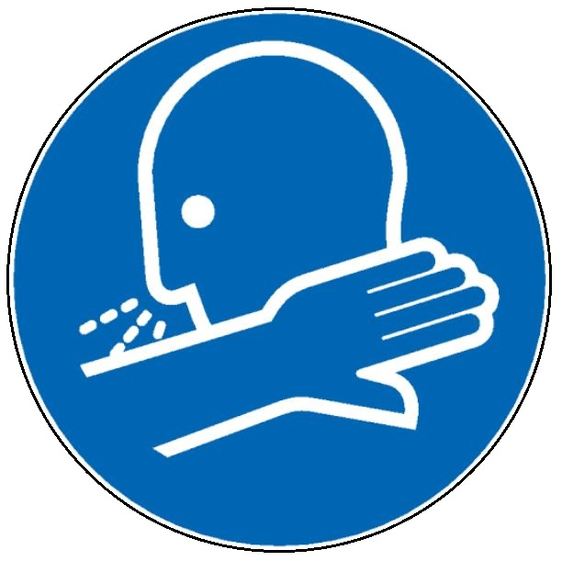  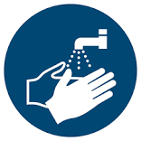  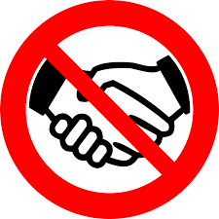 |  |  |  | - Keep distance  Avoid groups of people, keep minimal distance of 1,5m to others  Avoid unnecessary physical contacts like hand shakes, hugs and kisses  - Wash hands regularly  Remove all jewellery and wash thumbs, palms, back hand and in between the fingers as well as around the nails for at least 30 seconds with soap. Then rinse your hands under running water and dry them with a clean paper towel.  - You may also use hand disinfection for at least 30 seconds. Carefully distribute to thumbs, palms, back hand and in between the fingers as well as around the nails.  - Keep your hands away from your face  Avoid touching your face with your hands, especially when you wear Mouth-Nose-Protection. Avoid continuous corrections of the protection mask.  - Coughing and sneezing etiquette:  Whilst coughing or sneezing keep distance to others. Use paper tissues and cough/ sneeze into the croock of your arm. Dispose paper tissues into a closed bin.  - Ventilation:  Closed rooms should be aired regularly.
 | First Aid

Behavior in case of symptoms: People who were in close contact with a person verified as infected with the SARS-CoV-2 virus should immediately contact local health authority, consult a doctor or call 116117 – and stay at home.

People who think they are infected with the SARS-CoV-2 virus should contact their doctor by phone or go to the hospital. Follow your doctor´s intrcuctions and inform the management of Avaya.

Protect yourself: Use gloves and repiratory masks when you have contact with infected people. If this is not possible, keep distance.
Proper Disposal
 | Use impermeable plastic bags for disposal.
 | Responsibility
 | Date: Responsible:

